Developing Addition Fact Fluency in Second Grade Students:
A Study on Developing Number Sense and Basic Addition Fact Fluency
in a Second Grade Classroom

Timothy Tutt

Submitted to Dr. Vicki Seeger
In partial fulfillment
Of the course requirements for
61-697 Academic Inquiry
For the Curriculum and Instruction Master’s Degree Program

Fall 2021

Introduction
Second graders in a large, urban school district in Iowa had a year-round, overarching, priority standard stating that students could “fluently add and subtract within 20. By the end of Grade 2, [students will] know from memory all sums of two one-digit numbers” (Carson-Dellosa Publishing, 2.OA.2.).
Fluency “requires that students be fast and accurate when solving basic facts” (Baker & Cuevas, p. 13). In this district, second grade students were expected to fluently add or subtract within 20 at a rate of no less than 15 correctly solved problems in one minute, or any one problem solved in four seconds or less. As is the case every year, there was a substantial subset of students in my classroom who struggled to make it to this goal in addition, which usually ranges between 25-50% of the class.
Starting in the 2021-2022 school year, the district gave second graders tests on mathematical automaticity three times; in September, January, and May. Automaticity is “the ability to deliver a correct answer from memory without conscious thought” (Baker & Cuevas, p. 13). Baker and Cuevas add that automaticity must be achieved first if fluency is to be mastered (p. 13).
In the fall of 2020, while I was enrolled in a previous course for my Master’s Degree, Feedback and Goal Setting, I devised a plan to develop addition fact fluency. The project received high marks from my professor and coach. It also seemed to be working with the students with whom I tried it. However, the conditions for implementation of my approach were unique as no more than half of the students were ever present during the height of the COVID-19 pandemic in the late fall of the 2020-2021 school year.
I wanted to try this work again in 2021-2022, under better circumstances.
I wanted to try this work again, with scholastic research supporting my efforts.
In the intro to their book, Mastering the Basic Facts in Addition and Subtraction (2011), Susan O’Connell and John SanGiovanni state that “Our students are so different, and yet our goal for each of them is the same: to master basic math facts so they have a strong foundation for more complex math skills and procedures” (p.1).
I share the same goal for each of my students.

Setting
The elementary school where the research will be conducted is one of 38 elementary schools in a large urban school district. As of November 1, 2021 there were 355 students enrolled in the school - which has a free- and reduced-lunch rate of 51%, with 45% of students not being identified as white. The second-grade classroom where students had been chosen for this research had 22 students. The free and reduced lunch rate in the classroom of study is 57%. 50% of students in this classroom of study are not identified as white. Ten students identify as female (45%), with the remaining 12 students (55%) identifying as male. English Language Learning services are offered to 24% of students in this class.

Participants
I plan on focusing my action research project on seven students. Using samples of work from the first month of school, I have placed the students into three groups. The first group will consist of two students, both girls, who showed that they were considerably below grade level in math. Neither were able to answer more than four facts correctly (of 30) on two 60-second, addition fact timed tests that I’m using as a pre-assessment for this research. These two also struggled with counting from 1-20 in written form. I wonder if the counting activities embedded in this project will help these two students develop some number sense and strategy that can be applied to developing fact fluency?
For all seven students, were motivating techniques utilized in the research, such as student-centered goal setting and positive engagement with the teacher in individual sessions, lend to a better sense of concentration or focus on the work of developing addition fact fluency?
The second group of students consisted of three students, two boys and one girl. Their addition fact work so far this school year had shown that all had counting skills and number sense, but could stand to learn more strategies to aid with automatic recall and/or faster computation. One student in this group had severe anxiety concerns and is inconsistent with work completion because of them. With this group, I wondered if the practice activities on fluency and automaticity, and the goal setting and self-evaluation sessions with the teacher would have a positive effect their outcomes, having shown increased rates of addition fact fluency over the course of the research?
The third, and final, group consists of one girl and one boy who was able to show early signs of meeting the district fluency standard of correctly answering 15 problems in one minute. With these two, I wondered if the activities and one-on-one sessions led to increased rates of fluency and more application of automaticity that could lead to rates between 20 and 30 correctly-solved addition problems per minute? Also, even though it was not noted in this research project, would any increase in their addition fluency outcomes lend to fluency and automaticity with subtraction facts within 20?

Review of the Literature
There are four resources that have been primary drivers of the research. The first resource is a journal article, “The Importance of Automaticity Development in Mathematics”, written by Austin Baker and Josh Cuevas and published in the Georgia Educational Researcher (2018). Baker and Cuevas confirmed the importance of automaticity and fluency in mathematical development, stating “not only does automaticity help with general math automaticity in math facts, it is fundamental to success in many areas of higher mathematics” (p. 13). The article also confirmed two preconceived notions that I had about the acquisition of fluency and automaticity, stating that “students with learning disabilities or low academic performance show considerable difficulty with automaticity” and that they “are more likely to rely on counting strategies than direct retrieval when working with single-digit fact problems.” (p.13). This article also states that, “fluency in basic facts… affects the student’s progression in mathematics” (p.13) as “students who were computing simple addition problems made the most errors in the miscalculation of a fact and not with the addition algorithm” (p.13).
A second resource that helped shape my research is another journal article, “Fluency as a Function of Conservation Ability in Young Children”, written by Zane Wubbena for Learning and Individual Differences (2013). Wubbena performed his research on 97 first-grade children from two low-socioeconomic schools in central Texas. He worked with students on addition and subtraction fact fluency, along with a hands-on activity measuring water. From that initial work with students, Wubbena sorted students into two groups: conserving students were able to process numbers and make connections between counting, addition, and subtraction. Non-conserving students were not able to do so (p.154).
While I did not replicate Wubbena’s work, his study led me to want to pre-assess the students in my study to check for number sense – the ability to make connections between numbers, and the values or quantities represented by them. I have created some alternate activities for those in need number sense development using manipulatives and counting strategies before working on addition fact fluency, as Wubbena did in his study. His work also has led me to create two groups within my research. He sorted students into “conserving” and “non-conserving” groups. The students who struggled the pre-assessments will have counting sessions with me, to develop counting skills and number sense. Those not needing that after pre-testing will meet with me for fact fluency sessions, starting their fluency strategy practice on their first session.
A third resource that has helped shape this research project is Math Fact Fluency: 60+ Games and Assessment Tools to Support Learning and Retention by Jennifer Bay-Williams and Gina Kling (2019). Bay-Williams and Kling state that “basic facts truly are the foundation on which all mathematical computation is based” (p. vii).
Kling and Bay-Williams work has also rooted my action research and the philosophy behind it in listing five fundamentals that define the goals of math fact mastery:
- Mastery must focus on fluency – being accurate, efficient, and flexible (applying efficient knowledge to solve other mathematical uproblems) (p. 2).
- Fluency develops in three phases; counting with objects or mental counting, deriving an answer using a strategy or connecting with another fact, and showing mastery by efficiently producing answers (p. 4).
- Foundational facts (+0, +1, +2, fact doubles, combinations of 10, and +10) must precede derived facts (p. 5).
- Timed tests do not assess fluency (p. 8).
- Students need substantial and enjoyable practice (p. 10).
My fourth primary resource that has been integral in the formation of this research project has been the book Mastering the Basic Math Facts in Addition and Subtraction, by Susan O’Connell and John SanGiovanni (2011). The contents of their book have confirmed the sequence and structure of the fluency plan I have created and used with some students last year, emphasizing the learning of foundational facts first, and building upon them. Setting goals with the students, using manipulatives and games, and creating sessions that would minimize anxiety is also supported by O’Connell and SanGiovanni’s work.
My ultimate desire in doing this research is that all of the students in the study will have increased outcomes with their addition fact fluency, and automaticity; in their ability to do the math, to understand it, and to develop their confidence in math in the process. In the words of Susan O’Connell:
Our goal is to build strong mathematicians. Mastery of math facts is an important step toward that goal. If math fact instruction is thoughtful and strategic, it results in more than a student’s ability to quickly recall a fact, it cultivates… a flexibility of thinking that allows [students] to understand connections between mathematical ideas (p. 144).

Action Research Questions
The following questions help define the work and focus of this research project:
- What impact does a 3-step plan I have created using number sense, automaticity, and fluency strategies have on students’ mastery of addition facts within 20?
- What impact will counting activities for students struggling with number sense have in developing addition fact fluency?
- Will teacher-guided, student-directed goal setting and evaluation of sessions positively affect student engagement during practice sessions?

Data Sources
The following sources of data provided documentation and evidence in answering the action research questions. Some documents listed below in are listed more than once, as they helped answer more than one of the research questions.
For Question 1: What impact does a 3-step plan I have created using number sense, automaticity, and fluency strategies have on students’ mastery of addition facts within 20?

- Pre-Assessments: I had given each student two Mad Minute timed tests with 30 addition basic facts each (Appendix A1 and A2). These same documents were also used to document progress during the middle and at the end the research period. This will be kept in a 3-ring binder for teacher use only, to which I will refer as the teacher binder (Appendix A3). I also gave each student a sheet that asked for them to count to 20 in writing (Appendix A4). This document is what I used to determine if a student was ready to start the fluency strategies, or if interventions in counting and numeration were needed for students before beginning fluency strategies.

- Pre-Assessment and Post-Assessment Spreadsheet: I created this document to record scores from the Mad Minute pre-test and counting pre-tests (Appendix A5). Any alternate assessments given as supplementary data in addition to the Mad Minute sheet were recorded on this document. This document will be kept in the teacher binder, along with a digital copy stored in a cloud file.

- SMART Goal Planner for Addition Fact Fluency: This self-created document was kept in the student’s math fluency folder, documenting completed work and progress toward achieving counting goals that I consider pre-requisite to understanding and learning addition facts, and developing fact fluency (Appendix A6).
For Question 2: What impact will counting activities for students struggling with number sense have in developing addition fact fluency?

- SMART Goal Counting and Number Sense Log: This self-created document was kept in the student’s math fluency folder, documenting completed work and progress toward making a connection between numbers up to 20 and the values they represent (Appendix A7).

- Counting/Number Sense Assessment Spreadsheet: This self-created document is to be used by the teacher to document work completed by students working on counting and number sense strategies. This document was stored digitally in a cloud file.

For Question 3: Will teacher-guided, student-directed goal setting and evaluation of sessions positively affect student engagement during practice sessions?

- SMART Goal Planner for Counting and Number Sense: This student work log was kept in the student’s math fluency folder, documenting completed work and progress (Appendix A7).

- SMART Goal Planner for Addition Fact Fluency: This student work log is to be kept in the student’s math fluency folder, documenting the students’ completed work and progress. Fact fluency goals are listed on this document (Appendix A6).

- Addition Table: This teacher-created document was on the back side of the SMART Goal Planner for Addition Fact Fluency. It lists all 121 addition facts with sums up. to 20. The teacher highlights all the sums that were correctly and fluently (under 4 seconds) in a session, so students could ser their progress over the sessions (Appendix A8).

- Entrance and Exit Survey Sheet with Goal Setting: This self-created document was used as a guide throughout the counting or fact fluency sessions with individual students. The teacher used this document as an interview guide, asking individual questions, and transcribing answers from students. There is also a place on the document that allows the teacher to take anecdotal notes from the student session. The teacher kept copies of the Entrance and Exit Sheets in each student’s math fluency folder. The most recent copy of the survey will remain in the student’s folder for their review (Appendix A9).

- Session Assessment Spreadsheet: This self-created document was digitally created and used by the teacher to document the student goals and outcome.

Assessments
The impact of the action research was measured using multiple assessments.
As was mentioned earlier, all students in class participants completed two addition timed test sheets with 30 addition facts of sums less than 20. Students who were not able to answer five questions correctly on both timed tests were given a mixed set of counters, labeled from 1 to 20. They needed to sequence the counters in order.
After pre-testing was completed, two types of study sessions took place during the course of the research between the seven individual students and their teacher after the pre-assessments: counting sessions for those who struggled with number sense, and the fact study sessions for those who were ready to begin practicing fluency and automaticity strategies.
Students who struggled with the timed test pre-assessment, could have opted to take an alternate pre-assessment: a flashcard timed test or try one of timed fluency games on the computer have linked to my classroom website, bigtsclass@weebly.com. However, I did not push those alternate assessment options for the pre-testing phase unless the student insisted. A child with initial poor number sense is unlikely to fare much better with an alternate assessment, yet someone with handwriting and/or fine motor concerns may fare better with alternate assessments.
Students who did not show signs of automaticity or number sense needed to first complete a series of activities that would help develop counting strategies up to and down from 20. If needed, another student can partner with the one who is struggling to provide help and guidance between sessions with me. To test out of this level, students need to be able to count to 20 orally, correctly arrange numbered counters from 1-20 using ten frames, and be able to count up and down 1 or 2 numbers from 1-20, with or without using visual aids. When (if) that was achieved, it was be noted on a “SMART Goal Planner for Counting and Number Sense” for the students and on a spreadsheet that I keep for my records.
Students who showed an ability to count up to, and down from, 20 with ease, and showed either automaticity or strategy in solving addition facts began immediately with the fact study phase, which consists of a 12-level set of challenges, listed in the SMART Goal Planner for Addition Fluency.
Students chose the level on which they wanted to work and be assessed as a session with the teacher begins. At the beginning of each fluency session, students rated themselves on how they felt about the new session and the level they were on: Level 3 (feeling good) was indicated by a smiley face (). Level 2, a plain face (), indicated some apprehensiveness, and Level 1, a frown face (), indicated that the student though the session was, or was going to be, difficult. As each session began, each student also chose if they wanted a mini-lesson, practice time, or to go immediately to the level assessment.
In the level assessment given during the session, students used flash cards to orally answer 80% of the facts in that level accurately and in less than four seconds – the fluency standard for second graders in this district. Problems that were solved erroneously or longer than four seconds were noted in a section for anecdotal notes on their SMART Goal Planner. Those problems were visited in the student’s following session and tried again at that time.
Here are the 12 levels to be completed on the SMART Goal Planner, shown in Figure 1.

Figure 1
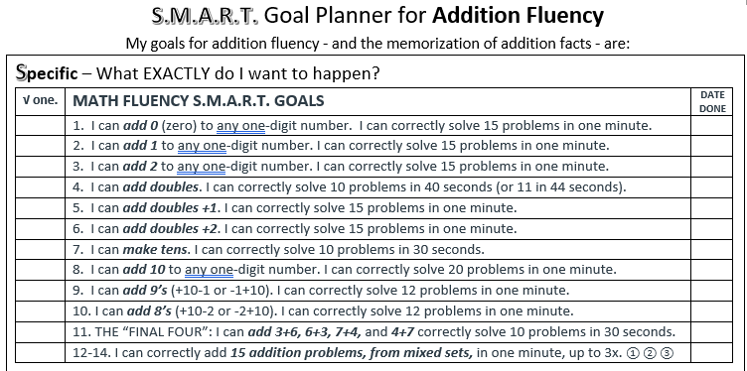
The first level of the fact study phase is “I can add 0 to any one-digit number.” The final level is to be able to “correctly add 15 addition problems, from mixed sets in one minute, up to three times.” This final assessment can be done as a written timed test, using print or digital flash cards, or playing one of a variety of computer addition fluency games accessed through the classroom website, http://bigtsclass.weebly.com. Students chose which levels to practice, and the manner of assessment.
The completion of these levels were documented in the SMART Goal Planner for Addition Fluency for the students. Correctly-solved problems were highlighted on an addition table on the back side of the SMART Goal Planner. Anecdotal notes were taken on the Entrance and Exit Survey for the student’s session.

Implementation of the Action Research
The table below is a timeline of this action research project. The table lists the action steps involved in implementing the research along with proposed dates for those steps. I have also included the people who have helped to support the research, and the types of documentation I plan to collect as evidence of the research.
Action Steps | Timeline | Support Needed | Documentation
The principal was informed of the Action Research plan, and shown this timeline. | 10/13/21 | Building principal,  Instructional coach | Self-created form, signed by the principal stating that the action research idea was presented.
Student completes two pre-assessment activities:  1. All students will complete a Mad Minute addition fact timed pre-test, with 30 randomly-selected problems with sums of 18 or less. Students will have one minute to solve problems.  2. Likely candidates who struggled with the written timed test will arrange 20 counters from 1-20, using a ten-frame template. | 10/20/21 - 10/26/2021 | Participating students | 1. Mad Minute timed test – 30 problems with sums up to 18  2. Spreadsheet documenting pre-test scores for the timed test and counting.  3. Computer file to store pictures of the counting activity  4. Student participation log documenting each step of participation.  5. Folder for each student to collect their work.
Discussing the research project to parents/guardians of selected students during fall conferences | 10/26/21 - 10/28/21 | Participating students, parents or guardians of participating students | Self-created letter, highlighting the rationale for, and goals of, the action research.
Based on results of the pre-testing;  1. Start a series of activity-based counting sessions, focusing on counting up to 20 and down from 20.  2. Start a series of activity-based fact study sessions, focusing on addition fact fluency strategies. | 11/3/21 – 12/3/21 | Participating students | 1. SMART goal counting activity log.  2. SMART goal addition fact strategy log.  3. Both logs will be kept in the fact fluency folders that were made for each student.  4. Goal setting sheet, with an entry and exit slip to be completed each session.
Independent student practice on counting or fact fluency activities between sessions with teacher | 11/3/21 – 12/3/21 | Whole class | Practice log, kept in student math fluency folder
Sent home counting or fact strategy homework once a week for optional extra practice. | 11/7/21 – 11/29/21 | Participating students, parents | - Counting worksheets  - Mad Minute sheets with sums under 10
Assessments given at the end of the research period. (NOTE: The work will continue as an intervention throughout the year, or until all of the addition strategies have been mastered)  Students may have opted for alternate assessments, using a computer or flash cards. | 11/30/21 – 12/3/21 | Participating students | 1. Mad Minute sheet, with sums to 18 – making copies of the same sheet that was given as a pre-test at the beginning of the research.  2. A spreadsheet, documenting the three final assessments for each participating student. To allow for easy comparisons of data, this will be the same document used to record the pre-test scores at the beginning of the research.
Research update sent to parents. | 12/12/21 - 12/15/21 | Participating students, principal, parents | Letter written to parents of participants
Whole-Class Celebration of fact achievement | TBD – later in the school year | Whole class of students, teacher, instructional coach, vice principal, principal | Award certificates given to all participants

This timeline highlights three primary sections of research: notification and pre-testing, strategic fact practice, and final assessments. The pre-testing phase research began with getting baseline information on the students’ counting and addition fact knowledge prior to studying addition facts. Pre-testing took of the entire class took place in late October, before parent conferences were held on October 26-28. Students selected for the research and their parents were notified of the research project at this time. As was mentioned in the timeline, there was a primary pre-test - a Mad Minute sheet with 30 problems with sums to 18. I recorded pre- and post-testing scores in a 3-ring binder.
During the month of November, students applied skill practice on one of two tracks… the counting and number sense track, or a fact fluency track. Each student being researched met with me once or twice each week for 5- to 10-minute sessions. Each session opened with students setting a goal for the week, followed by fact practice, in which the goal may, or may not, have been met. Sessions started and ended with a self-evaluation entrance and ended with an exit survey, expressing how each student felt about their current fluency or counting goal. The entrance and exit survey consisted of three faces (Level 3) , (Level 2), and (Level 1), with space on the form for the teacher to write the goal and summarize what the student had to say about it. Student records were kept in a “Math Fluency Folder”, which I stored in a bin with my three-ring binder.
These interventions took place over a 30-minute period already allocated for math intervention. Control students and experimental students not in sessions with me at that time were required to do an activity listed on a practice log that was posted (Figure 2).
Figure 2
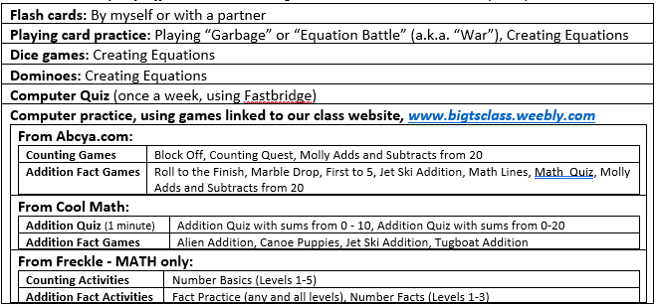
At first, I gave those students choices from the chart, but that became difficult to manage. I then would assign a math assignment from the choice chart, usually a fact-fluency, counting, or fact practice game students could quietly the computer. I often chose time on Freckle.com as I worked directly with individual students, as their work and practice could be monitored.
I also felt the need to reserve time – either 10 minutes on a given day, or for an entire intervention period one day a week – to hold “office hours” open to all students who need help and guidance for math skills that are being taught at the time
The last week of research for the submission for this project was focused on assessing any progress that was made after a month of practice. The assessment phase is repeat of the pre-test process. Students will need to complete a different copy of the same Mad Minute sheet that they took as a pre-test. Alternate assessments using either the computer or flash cards will be made available to students.
Even with the research plan in place, I had many concerns. In a five-week period, I did not expect all of the students to reach the overarching addition fact fluency standard of being able to correctly solve 15 addition facts within 20 in one minute. That, along with subtraction fact fluency within 20, are standards – i.e. goals - for the duration of the school year. I hoped that the research would show an increase in students’ number sense or in their rates of fluency over a six-week period.
At the end of the research period. I wanted to celebrate the work of both the control students and experimental students with a Class Reward Party. This is an extrinsic motivator and my way of showing gratitude for the participation of everyone in class, where they were actively involved in sessions, or potential candidates for another round of research involving then, should the findings of the work prove to have positive effects on student outcomes and attitudes toward addition fluency.

Data Analysis
I collected data on pre- and post-assessments, learning counting and fact fluency strategies, and entrance and exit survey information in various ways. Listed below are the ways in which I gathered data for each of my research questions:
Question 1: What impact does a 3-step plan I have created using number sense, automaticity, and fluency strategies have on students’ mastery of addition facts within 20?

For the first step of this plan, I collected pre-test data using Mad Minute timed tests (Appendix A1 and A2) and a sheet I had created to assess my students’ counting abilities to 20 (Appendix A4). I recorded this information on a pre-assessment spreadsheet, a paper document.
For the second step of my plan, I documented information from the intervention session on a “SMART Goal” sheets I created to collect data to assess how well students were mastering strategies needed for counting (Appendix A7) and for addition fluency (Appendix A6). As students were learning fluency strategies, I recorded the facts they could automatically recall (or answer in less than four seconds) on an addition table on the back side of the SMART Goal sheet for addition fact fluency (Appendix A8).
For the third step, I collected post-test data from Mad Minute sheets. At the end of that assessment, I converted the data from the pre-assessment spreadsheet into an Excel document, added the post-test information, and created formulas to compare pre- and post-test data.

Question 2: What impact will counting activities for students struggling with number sense have in developing addition fact fluency?

For this question, I gathered data on counting number sense from the counting pre-test I had given (Appendix A4), then recorded it on the original pre-assessment spreadsheet (Appendix A5). Only two of the seven students needed extra work with counting and number sense. Their data was collected on a form labeled “SMART Goal Planner for Counting within 20” (Appendix A7).
Question 3: Will teacher-guided, student-directed goal setting and evaluation of sessions positively affect student engagement during practice sessions?

Students chose fluency or counting intervention strategies, which I recorded the results of that work using the SMART Goal planners for addition fluency (Appendix A6) or counting to 20 (Appendix A7). Student attitudes going into each session, and exiting each session were recorded on an entrance and exit survey I created (Appendix A9). Those results were compiled on a spreadsheet, with the averages compiled.
Changes Made
Changes were made during the research process. Most changes took place in the timeline. Other changes took place as I realized that time was in short supply.
One of the reasons for the timeline changes happened because new resources were offered for the research and implementation by leaders in my building as I was wanting to start the implementation of the interventions. My principal – a former math coach – along with the instructional coach in my building, informed me that the Fastbridge program that our district started using in 2020-2021 to assess math automaticity, provides optional intervention activities for number sense and fact fluency. Fastbridge also offers fact fluency assessments which can be customized by staff and taken weekly by students. Learning about the program as I was preparing to begin my research, pushed my implementation plan behind. Once I began with one-on-one sessions, I realized that implementing the Fastbridge program to my work added another layer, for which I did not have time. However, I still hope I can use it for my next round of implementation of this fluency plan.
Another change that has taken place between the conception and implementation of this project is that I needed to reduce the number of students I was researching from ten to seven. When I first started planning on the research, I was hoping to involve the work of all 21 students. As I looked at the reading interventions I gave in my homeroom class this year, I was reminded that providing interventions for nine students was challenging. Having less time embedded in my schedule for math intervention, yet still serving the needs of all 22 students, I realized that documenting the work and research of 10 was too many. Instead of monitoring the work of three students who struggle, four who work at grade level in math, and three who excel, each group was reduced to two students each, totaling six students whose work was researched.
My final challenge I encountered with the research was time. This challenge had shown itself in the following ways:
- I spent too much time engaging with students. I often find that students (and I) enjoy one-on-one conferencing time. While the banter taking place between me and the student made sessions last somewhat longer, the relationship building that took place provided rewards that were reaped beyond the math interventions.
- Other students would make demands on the time I was having during sessions.
- One student – who has struggled greatly with understanding numbers – has had inconsistent attendance, which provided her with fewer opportunities for practice.
- When I first drafted the timeline, I was not aware that the students had a four-day “fall break” after conferences at the end of October and the beginning of November 2021, which was actually a six-day break with the weekend included. That took nearly a week off from the research timeline.

While these changes were significant in the implementation of the research, none of these changed its scope.

Results and Findings
In only four weeks of implementation and three weeks of one-on-one interventions with students, I could see positive trending on student outcomes; in their increased fluency, and in their attitudes about engaging in strategies to make learning addition facts meaningful and easier.
Question 1: What impact does a 3-step plan I have created using number sense, automaticity, and fluency strategies have on students’ mastery of addition facts within 20?
Table 1
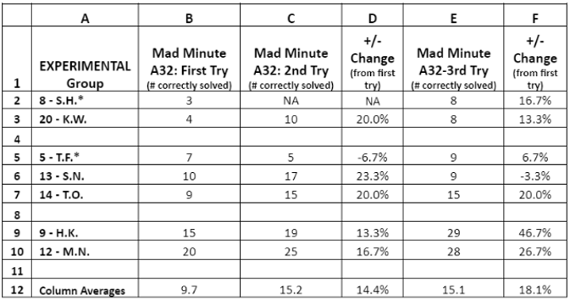
Table 1 shows seven students in the “experimental group”. Student #8 and #20 needed to start with counting and numbers sense activities before practicing fluency strategies. Student #8 has had difficulty with attendance, with number concepts, and participation in class activities. In the written counting pretest, this student could only write “1” and “2” when asked to write numbers to 20. Student #5 has issues with severe anxiety and may need to not be timed in the future.
All seven people who were involved in the experimental group showed increased outcomes on at least one of their two follow-up their Mad Minute timed tests assessment (Appendix A1) over a three-week period of addition fluency and/or counting interventions. Five of the students – students #5, #9. #12, #14, and #20 (rows 2,3,5,6,7,9, and 10) - increased their scores on both follow-up tests the assessment. The other two – students #8 and #13 (rows 2,6) - increased their scores, but not both times. However, those two students still were part of the overall increase of scores that were higher than their initial pre-assessment.
Looking at columns D and F in Table 1, nearly every student shows at least one test with a double-digit percentage increase - except for Student #5 with a 6.7% increase. The collective increase for the entire experimental group (column D, row 12) is when taking the Mad Minute assessment is 14.4% over the original testing. The collective increase from the first Mad Minute assessment to the third assessment at the end of the research period after three weeks of intervention (column F, row 12) was 18.1%.

Table 2
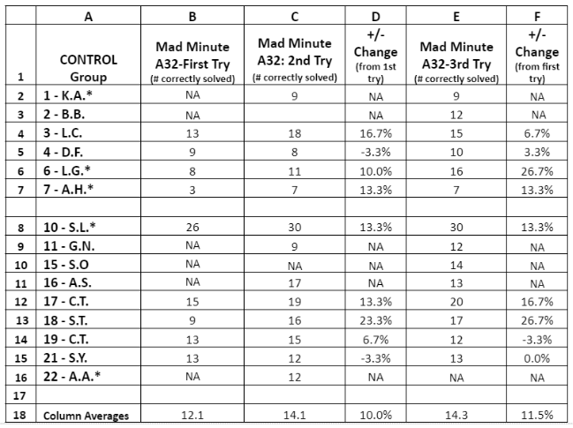

Table 2 shows the scores of the Mad Minute Assessment with the of the students in class – the control group. group taking another Mad Minute timed test assessment. Comparing columns B and C show an improvement in scores for five of the seven students. 5The control group has shown growth between the three times that Mad Minute #A32 was given - amidst many absences, marked as “NA”. Their interventions were on mostly computerized while I worked with individuals within the experimental group.
Column D, Row 12 in both charts show that the experimental group showed growth rates of 14.4% between the first and second taking of the Mad Minute test, and 18.1% between the first and third taking of the same test. The control group showed growth rates of 14.1% and 14.3%.
While both classroom groups experienced growth, the experimental group showed a higher rate of growth over the course of the research.
Question 2: What impact will counting activities for students struggling with number sense have in developing addition fact fluency?

I chose Students #8 and #20 for this study due for three reasons, (1) their poor performance on the counting pre-test AND Mad Minute pretests, (2) noticeable difficulty with adding 0 or 1 to a one-digit number, an (3) a lack of participation and attention during math lessons. For these reasons, I knew they would be an experimental group for counting skills. My goal for them was twofold, that each of them would be able to count to 20 with ease, and have a strategy to add 0, 1, and 2 to each digit.
For these two, my immediate goal for them was not developing fluency; I wanted them to develop their confidence.
Table 3A
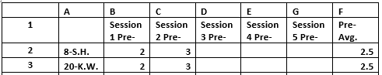
Table 3B
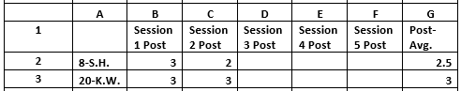

Tables 3A and 3B contain 2 sets of data points (columns B and C). Table 3A are the ratings the students gave themselves going into a session on the entrance and exit survey (Appendix A9). Table 3B are shows how each student rated themselves at the end of their session, which is also on the same form as the entry rating. These numerical values are based the type of smiley face they circle on the entry and exit survey. The faces and their values are shown in Table 4 below.
Table 4
Level 3 – I’ve got this! | Level 2 – I sort of get it! | Level 1 –This is hard!

For the first quarter of the year, I could not get either of these students to willingly participate in math lessons. During the research period, I worked with both students together and separately. Both participated, and even had smiles on their faces during most of their sessions! This was noted in the section on the survey for anecdotal notes. Even though the only levels of fluency practice they finished were adding zeros and ones, both were proud of their accomplishments as they often rated themselves with a Level 3 smiley. That would NOT have happened with a whole-class assignment at the beginning of the year.
Question 3: Will teacher-guided, student-directed goal setting and evaluation of sessions positively affect student engagement during practice sessions?

When coming up for a fact fluency or number counting session, I was stunned to observe that not a single student in the experimental group filled out the Level 1 “frown face” as they were entering OR exiting a session (Appendix B1). (The control group did not have sessions.) The observation group had an overall rating of 2.43 (out of 3) going into sessions with their teacher. The exit survey average score was 2.92.
I interpret these high ratings, an absence of Level 1 ratings, along with the increase in the timed test scores by all participants, as evidence that students are experiencing positivity, and that it is leading to positive outcomes with their fluency and in their engagement in mathematical activities.
Implications for Teaching and Learning
The overwhelmingly positive results in the research in a three-week period – both with the increased outcomes in fluency, and in the students desire to do the work between sessions, and in their participation in the sessions – provided evidence that (1) all of the students wanted to do the work, (2) that all students believed that they were making achievements, and (3) their fluency was increasing.
As I began doing the original project with my students in the previous year, I sensed something amazing happening with students. Every one of them, including some who had difficulty with learning their addition facts, or simply refused to make the effort to improve or care about their addition fact fluency, participated fully in my fluency sessions. The same held true for this round of research. One big difference between this year and last year is that my research led me to find activities to do with students who lacked the number sense needed to wrap their minds around the concept of what addition means. Even the two students I chose who struggled greatly with addition facts before the research, with one not being able to count past two in one of her pre-tests, increased their timed test performance between 13-16% in less than one month, were fluently adding their zero’s and one’s facts, and left every session with me by giving themselves smiley faces on their exit slips…every time.
Positive attitudes and positive outcomes – I’ve struggled with getting all students on board with motivating themselves to show automaticity by memorizing the basic addition facts up to 18 or 20 or have strategies in mind to quickly solve the problems that are not memorized. This process, which I have now applied twice with limited timeframes lasting less than a month, has proven a theory I have always had about students over my years of teaching…
All students want to be successful.
The learnings I have gathered from the data I’ve collected, and in the enhanced, mutual relationships and rapport I have gained in connecting with students confirms that I would like to pursue my plan further… with the remainder of my students this year, and to embed this plan as part of my intervention instruction in future years of teaching. I could also encourage implementing this plan as an instructional coach as a math intervention to homeroom teachers and interventionists.
Further Questions
Since the full implementation only involved one-third of my students for approximately one month, the biggest wonder I have is how much more will these seven students grow with another month or two of this intervention?
I had previously mentioned that the principal and coach had offered and recommended that I access and use online resources from Fastbridge, as I could get free online intervention resources for myself and the students, including computerized automaticity tests. I declined, mainly because of timing. Would the use of Fastbridge resources, especially the addition fact automaticity tests have increased student outcomes?
I also wonder how well I could implement this plan with more students… How would I fare trying this implementation with half, or all, of my class?
Also, I cannot help but wonder about the students who have struggled with basic number sense. Can I get the students’ growth in addition fact knowledge, understanding, and fluency to outpace others, so they can catch up? Or should I be content in knowing that they are simply increasing in their knowledge and outcomes?
I wonder if and how I can grow a list of stakeholders with this project, namely the students’ parents and guardians? How can I involve them in the development in their child’s addition fact fluency, and show them how addition fact fluency and automaticity make future math learning easier? Do I promote my website math links for home use? Do I offer short video lesson on addition fact strategies, so they can see how I use those same strategies with their children to encourage practice and reinforcement at home?
As I get my mind wrapped around full implementation of this project, could it be followed up with another research project on the connectivity between addition fact knowledge and automaticity and fluency with subtraction facts?
This project has reaped rewards and benefits for me and my students. I hope future implementation of this research continues to do the same for me, the students, parents, and other stakeholders who take interest in developing practices to enhance addition fact fluency and automaticity.
References
ABCya.com. (2021). Second grade math games. https://www.abcya.com/grades/2/numb

Addison-Wesley Publishing. (1981). The mad minute. Addison-Wesley Publishing Company.
Baker, A., & Cuevas, J. (2018). The importance of automaticity development in mathematics. Georgia Educational Researcher 14(2), 11-20.

Bay-Williams, J., & Gina Kling. (2019). Math fact fluency: 60+ games and assessment tools to support learning and retention. ASCD & the National Council of Teachers of Mathematics.

Carson-Dellosa Publishing. (n.d.). The complete common core state standards kit: Grade 2. Carson-Dellosa Publishing.

Cool Math 4 Kids. (2019). Math games, lessons, quizzes, manipulatives. https://www.coolmath4kids.com/

Dweck, C. [Stanford Alumni]. (2014, October 4). Developing a growth mindset with Carol Dweck. [Video]. YouTube.

O’Connell, S. & SanGiovanni, J. (2015). Mastering the Basic Math Facts in Addition and Subtraction. Heinemann.

Renaissance Learning, Inc. (2021). Freckle.com. https://freckle.com/en-us/
Sousa, D. A. (2008). How the brain learns mathematics. Corwin Press.

Tutt, Timothy. (n.d.). Big T’s class website: Practice websites. http://bigtsclass.weebly.com/practice-websites.html

Wübbena, Z. (2013). Mathematical fluency as a function of conservation ability in young children. Learning and Individual Differences, 26(2013), 153-155. https://doi.org/10.1016/j.lindif.2013.01.013

Appendix A

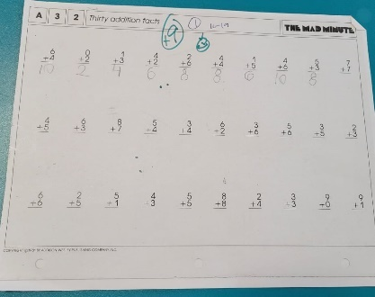 | 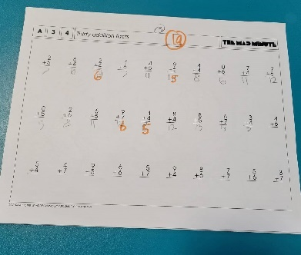 | 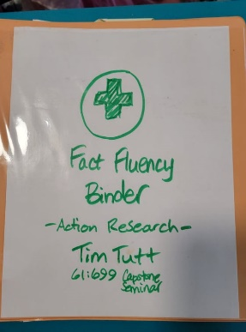
Appendix A1  Mad Minute Test #A32 | Appendix A2  Mad Minute Test #A34 | Appendix A3  Fact Fluency Binder
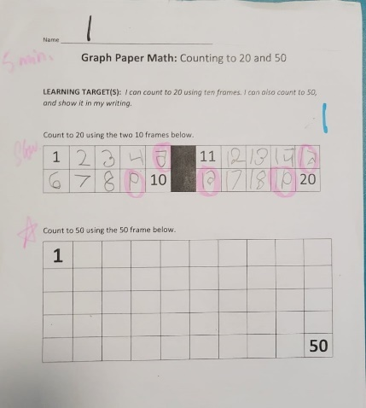 | 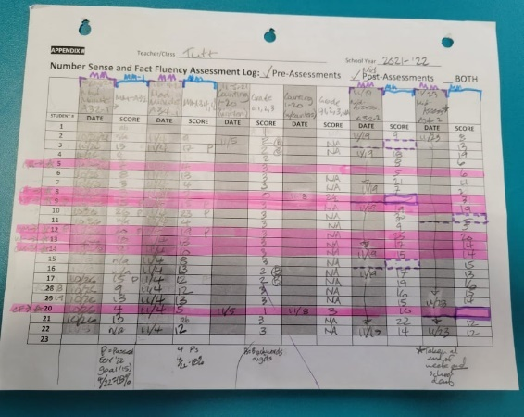 | 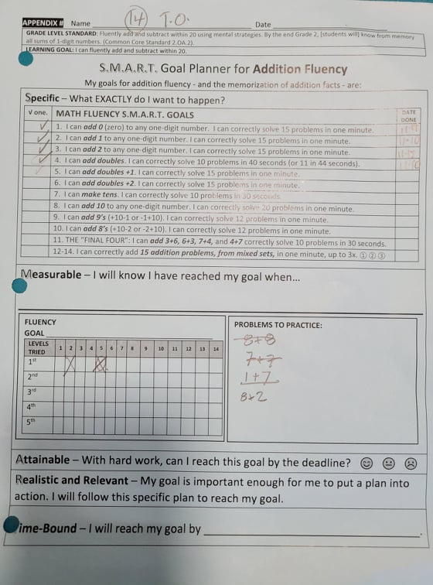
Appendix A4  Counting Pre-Assessment | Appendix A5  Assessment Spreadsheet | Appendix A6  Planner for Addition Fluency
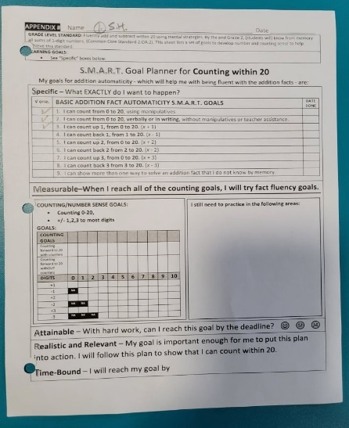 | 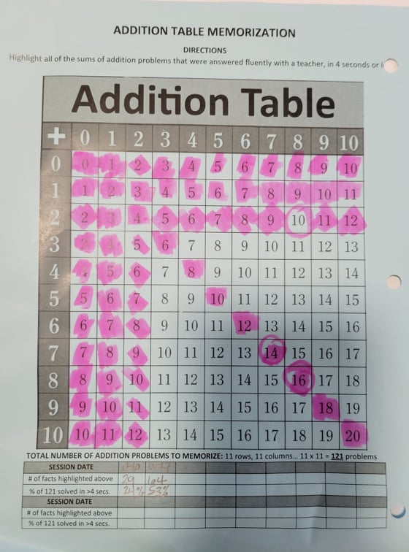 | 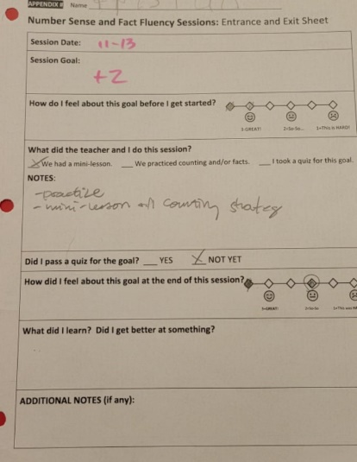
Appendix A7  Planner for  Counting within 20 | Appendix A8  Addition Table | Appendix A9  Entrance and Exit Sheet

Appendix B
Appendix B1
Ratings from Sessions of students in the observation group.
